**Accessing cmsrdp from off campus**

Please note the firewall settings on your local machine are not covered by this instruction.

1. Run RDP client mstsc.

Start->Run-> Type mstsc

1. Configure RDP client with full option.

2.1 Click ‘Show Options’ at left corner.

2.2 Go to ‘Advanced’ tab -> Settings

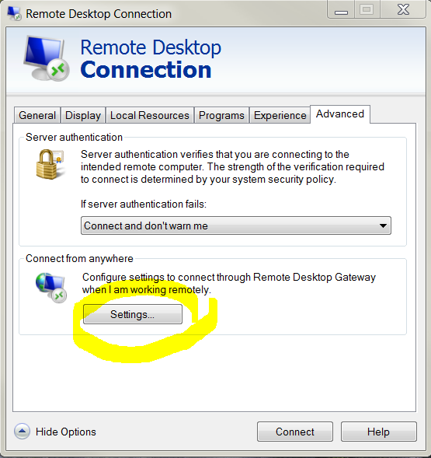

2.3 Configure RD Gateway as follows:

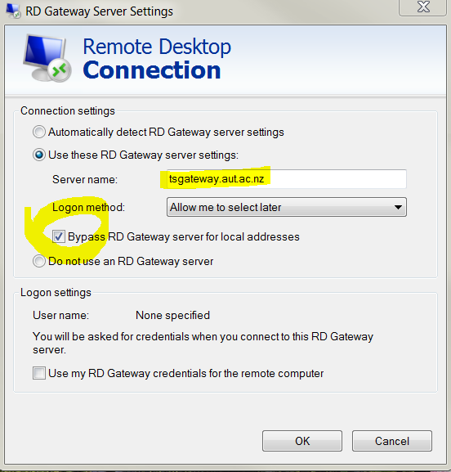

Note: Option to ‘Use my RD Gateway credentials’ is optional.

Click OK.

**Connecting to cmsrdp**

Configure RDP as follows:

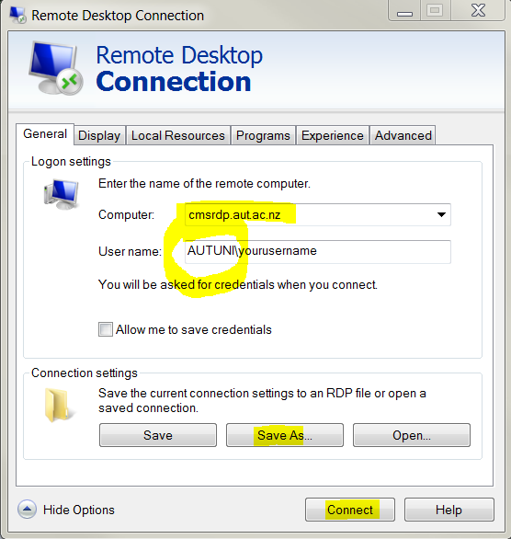

**Note**

1. AUTUNI\ is a must before your username. No space.

2. I recommend you ‘Save As’ this setting on your desktop or somewhere as a shortcut.

3. You may be asked to enter these details 2 times.

4. Connect and follow the on screen instructions, if any

**SQL Plus**

**Once connected, use the Start Menu > All Programs to find:**

Oracle 11g Suite > Oracle_OraClient11g_home > Application Development > SQL Plus

To log into SQL Plus you need to type in your username as: username@msdbs, to indicate the database you want to connect to. Msdbs is the database used in this class

Please note:

**username** is your AUT username.

**Password** is warehouse

